**DSCI-6004-01**

**FINAL PROJECT**



**Emotion Detection in Online Communications**

**Submitted by:**

**Navya Vemireddy**

***Abstract:*** *Emotion detection in online communications has emerged as a pivotal area in natural language processing (NLP), aimed at deciphering the intricate emotional cues embedded in digital interactions. This project delves into emotion detection in online communications, utilizing deep learning models and advanced NLP techniques. The primary focus is on developing a model for accurate emotion detection and classification, alongside NER, sentiment analysis, contextual understanding, and multimodal integration. Using the "Emotion Detection from Text" dataset, models like Multinomial Naive Bayes, SentimentModel, and BERT are trained and evaluated with metrics like accuracy, precision, recall, and F1 score. Text processing techniques such as tokenization, stop words removal, word embeddings, and sentiment analysis lexicons enhance data preprocessing and feature extraction. The deployment includes Gradio integration for real-time emotion analysis with image and text inputs using the BERT model. A star rating system further enhances user experience. The project's scope extends to future research areas like multimodal data integration, domain-specific model fine-tuning, and user-centric model refinement. This project advances emotion detection in digital communications, paving the way for empathetic and intelligent communication systems*.

***Keywords; Emotion detection, online communications, natural language processing (NLP), deep learning, sentiment analysis, named entity recognition (NER), text processing, deep learning models, BERT, Gradio integration***

1. **INTRODUCTION**

Online communication has become an integral part of our daily lives, spanning various platforms such as social media, email exchanges, messaging apps, and online forums. In these digital spaces, the ability to discern and understand the underlying emotions expressed by users is paramount for effective communication and engagement. Traditional methods of emotion detection, relying on rule-based systems or simplistic machine learning algorithms, often struggle to capture the nuances and complexities of human expression in these digital interactions. This limitation has led to a growing interest in leveraging advanced natural language processing (NLP) techniques, particularly deep learning, to enhance emotion detection capabilities. One of the key challenges in traditional emotion detection methods is their inability to handle the contextual nuances and varied expressions of emotions in online communications. For instance, a simple keyword-based approach may fail to distinguish between sincere statements and sarcastic remarks, leading to inaccurate emotion classification. Moreover, the dynamic nature of online conversations, influenced by cultural references, slang, and evolving linguistic trends, adds another layer of complexity that traditional methods struggle to address effectively.

Deep learning techniques offer a promising avenue to overcome these challenges. By leveraging large datasets and complex neural architectures, deep learning models can learn intricate patterns and semantic representations inherent in human language. This enables them to capture subtle cues, contextual nuances, and linguistic intricacies that contribute to accurate emotion detection and classification. However, despite the advancements facilitated by deep learning in NLP tasks, including sentiment analysis and named entity recognition, there are still significant gaps in the field of emotion detection in online communications. These gaps stem from several factors: Existing models often lack the ability to interpret contextual nuances such as sarcasm, irony, humor, and cultural references, leading to misinterpretations of emotions. Emotions in online communications are not limited to text alone; they may also be expressed through emojis, images, videos, and audio. Integrating these multimodal data sources poses a challenge for traditional emotion detection systems. While some models can detect basic emotions like happiness, sadness, anger, and fear, achieving fine-grained emotion classification (e.g., admiration, gratitude, boredom) remains a significant challenge. Many existing systems lack real-time processing capabilities, which are essential for applications such as chatbots, virtual assistants, and sentiment analysis tools used in live conversations and social media monitoring.Emotion detection in online communications raises ethical concerns regarding user privacy, data security, bias mitigation, and the responsible use of emotional insights.

The project aims to address these gaps and challenges by developing and evaluating a deep learning-based model specifically tailored for emotion detection in online communications. What sets this project apart from existing approaches is its comprehensive approach that integrates advanced NLP techniques, multimodal data processing, contextual understanding, and real-time capabilities. By leveraging state-of-the-art deep learning architectures and the "Emotion Detection from Text" dataset from Kaggle, the project strives to achieve accurate, robust, and ethically sound emotion detection capabilities that can enhance user experiences and communication effectiveness in online platforms.

1. **METHODOLOGY**
   1. **DATASET**

The "Emotion Detection from Text" dataset sourced from Kaggle played a pivotal role as the cornerstone for training and evaluating our emotion detection model. This dataset offered a rich collection of labeled text data, each annotated with associated emotions, providing a fertile ground for constructing robust models adept at handling a spectrum of emotional expressions. To prepare the dataset for modeling, we undertook rigorous preprocessing steps. This included meticulous text cleaning to eradicate noise and irrelevant elements, ensuring that the data maintained high quality and relevance for the model. Additionally, tokenization techniques were applied to segment the text into meaningful units, facilitating the model's understanding of semantic relationships within the data. Other advanced natural language processing (NLP) techniques were also employed during preprocessing to further enhance data quality and optimize model performance.

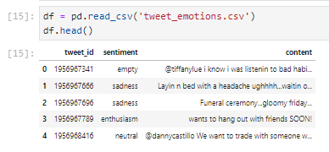

By leveraging the "Emotion Detection from Text" dataset and employing sophisticated preprocessing techniques, our project aimed to build a model that not only accurately detected emotions but also demonstrated robustness and generalization across diverse emotional contexts in online communications.

* 1. **MODELS**

1. **Multinomial Naive Bayes**

Multinomial Naive Bayes is a foundational probabilistic classifier widely used in text classification tasks. Its architecture is based on Bayes' theorem, assuming that features are independent of each other given the class label. In the context of emotion detection for online communications, Multinomial Naive Bayes serves as a simple yet effective baseline model. The architecture of Multinomial Naive Bayes consists of calculating the probability of a document belonging to a particular emotion class based on the frequency of words or features present in the document. It utilizes a bag-of-words representation, where each word's frequency is considered independently of its position in the text. This approach simplifies the modeling process but may overlook crucial contextual information and dependencies within the text. Despite its simplicity, Multinomial Naive Bayes holds importance in this topic for several reasons. Firstly, it provides a benchmark for evaluating more complex models. By comparing the performance of advanced models like neural networks and BERT with Multinomial Naive Bayes, researchers can assess the added value of sophistication in model architecture. Additionally, Multinomial Naive Bayes is computationally efficient and easy to interpret, making it suitable for initial explorations and rapid prototyping in emotion detection projects. Multinomial Naive Bayes has limitations, particularly in capturing contextual nuances and understanding complex linguistic structures. In online communications, where emotions can be subtle and context-dependent, this model may struggle to accurately classify emotions based solely on word frequencies. Therefore, while Multinomial Naive Bayes provides a solid starting point, more advanced models are often necessary to achieve higher accuracy and robustness in emotion detection tasks.

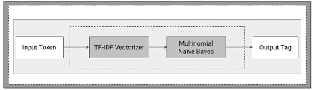

1. **Simple Neural Network Model (SentimentModel)**

The simple neural network model, often referred to as SentimentModel in this context, introduces a more sophisticated approach to emotion detection compared to Multinomial Naive Bayes. Its architecture typically consists of an input layer, one or more hidden layers with activation functions (e.g., ReLU), and an output layer with softmax activation for multi-class classification. Unlike Multinomial Naive Bayes, which treats features as independent, the simple neural network model learns non-linear relationships and feature interactions within the text data. This allows the model to capture more complex patterns and semantic representations, making it better suited for tasks where context and dependencies play a crucial role, such as emotion detection in online communications.

The importance of the simple neural network model lies in its ability to learn hierarchical representations of text features. By processing the text through multiple layers of neurons, the model can extract and combine features at different levels of abstraction, potentially improving emotion detection accuracy and capturing contextual nuances more effectively than simpler models. However, the simple neural network model also has its challenges. It requires careful hyperparameter tuning, sufficient training data, and computational resources to train and optimize effectively. Moreover, it may be prone to overfitting if not regularized properly, leading to reduced generalization performance on unseen data. Despite these challenges, the simple neural network model represents a significant advancement over baseline models like Multinomial Naive Bayes in emotion detection tasks. Its ability to learn complex patterns and semantic relationships makes it a valuable tool for enhancing emotion classification accuracy in online communications.

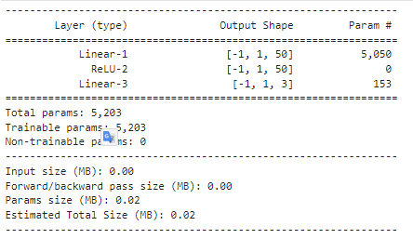

1. **BERT (Bidirectional Encoder Representations from Transformers)**

BERT, short for Bidirectional Encoder Representations from Transformers, represents the cutting edge in natural language processing (NLP) models. It is a transformer-based model that utilizes attention mechanisms and bidirectional training to learn contextual embeddings of words in a text sequence. BERT's architecture consists of multiple transformer layers, enabling it to capture long-range dependencies and contextual information effectively. Emotion detection for online communications, BERT's importance cannot be overstated. Its architecture allows it to understand contextual nuances, handle diverse linguistic structures, and capture semantic relationships within the text data. This makes BERT highly relevant for emotion detection tasks, where contextual understanding and nuanced interpretation of emotions are critical. One of the key advantages of BERT is its pre-training on large-scale corpora, which enables it to learn rich linguistic representations before fine-tuning on specific tasks such as emotion detection. By fine-tuning BERT on emotion-specific data, researchers can leverage its advanced capabilities to achieve superior performance in emotion classification, especially in scenarios with complex emotional expressions and varied linguistic contexts.

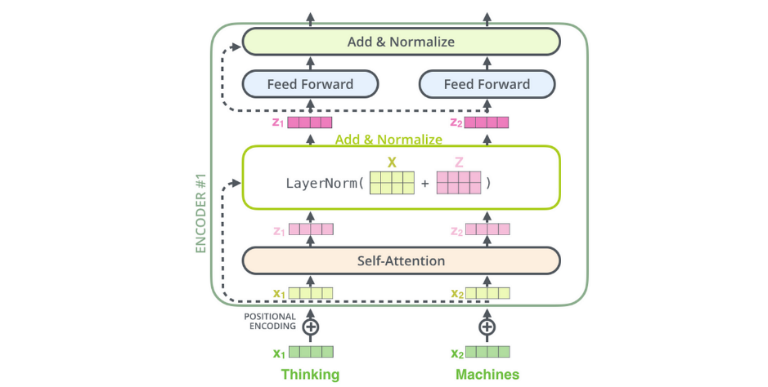

BERT's sophistication comes with computational costs. Training and fine-tuning BERT models require significant computational resources and time compared to simpler models like Multinomial Naive Bayes or simple neural networks. Additionally, BERT's large parameter size may pose challenges in deployment and inference in resource-constrained environments. Despite these challenges, BERT remains a state-of-the-art solution for emotion detection in online communications. Its ability to capture context, semantics, and long-range dependencies makes it a powerful tool for advancing research and applications in NLP, particularly in tasks related to emotion understanding and classification.

* 1. **TEXT PROCESSING**

1. Tokenization

Tokenization involves breaking down sentences or paragraphs into individual words or tokens. In emotion detection, tokenization plays a crucial role in segmenting text data into manageable units for analysis. For example, tokenization helps identify key emotional words or phrases that contribute to the overall sentiment of a message. Techniques like sentence tokenization can also be used to extract emotions from individual sentences within longer texts.

1. Stop Words Removal

Stop words are common words like "the," "is," "and," etc., that occur frequently in text but often carry little emotional or sentiment-related information. Removing stop words before sentiment analysis or emotion detection can improve the accuracy of the models by focusing on content-bearing words. This process is particularly useful in reducing noise and irrelevant information that may affect the interpretation of emotional content.

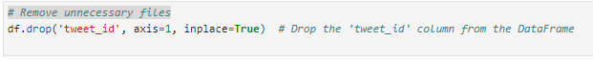

1. Text Cleaning

Text cleaning involves preprocessing steps to remove noise from the text data. This includes removing special characters, punctuation marks, URLs, and emojis that may not contribute directly to emotion detection but can interfere with the analysis. Emojis, while expressive of emotions, may require special handling to convert them into textual representations or sentiment scores for accurate emotion classification.

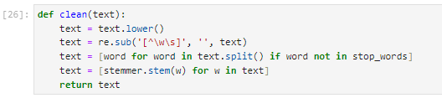

Word Embeddings

Word embeddings like Word2Vec, GloVe, and BERT represent words as dense vectors in a high-dimensional space, capturing semantic relationships between words. In emotion detection, word embeddings encode contextual information and semantic meaning, allowing models to understand the emotional nuances of text. For instance, word embeddings can capture the similarity between emotionally charged words and phrases, aiding in emotion classification tasks.

1. Named Entity Recognition (NER)

NER identifies and categorizes named entities such as names, locations, organizations, and dates within text. In emotion detection, recognizing named entities can provide additional context and help in understanding the emotional context of the text. For example, emotions expressed towards specific entities like companies, events, or people can influence sentiment analysis outcomes.

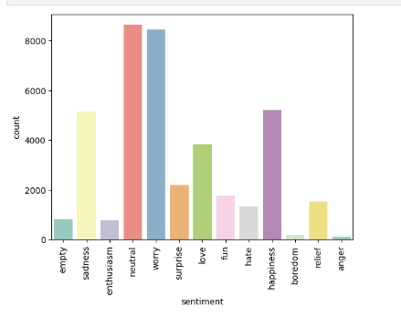

1. Part-of-Speech Tagging (POS)

POS tagging assigns grammatical categories (nouns, verbs, adjectives, etc.) to words in a sentence. This information can be useful for identifying emotional or sentiment-bearing words and phrases. Adjectives and adverbs often carry emotional connotations and can be indicative of the sentiment expressed in the text. POS tagging helps in capturing such linguistic features for emotion analysis.Checking the word pattern

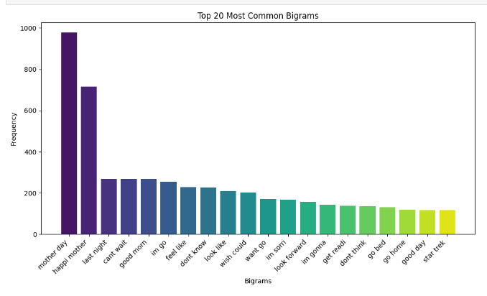

1. Text Normalization

Text normalization techniques like stemming and lemmatization reduce words to their base or root forms. This helps in standardizing text representations and reducing the vocabulary size, which is beneficial for model training and efficiency. Normalization ensures consistency in emotional expressions by treating variations of words (e.g., "happy" and "happiness") as the same entity, improving the coherence of emotion detection results.

1. Dependency Parsing

Dependency parsing analyzes the grammatical structure of sentences to identify relationships between words. While not directly related to emotion detection, dependency parsing can aid in understanding sentence structure and context. Identifying dependencies between words can reveal how emotions are expressed syntactically, contributing to a deeper understanding of emotional content in text.

1. Topic Modeling

Topic modeling techniques like Latent Dirichlet Allocation (LDA) and Non-negative Matrix Factorization (NMF) can identify underlying topics or themes in text data. Although not directly focused on emotion detection, topic modeling can provide insights into the content and context of textual data. Topics related to emotions, sentiments, or specific emotional categories can be identified through topic modeling, guiding emotion detection efforts in thematic analysis of textual content.

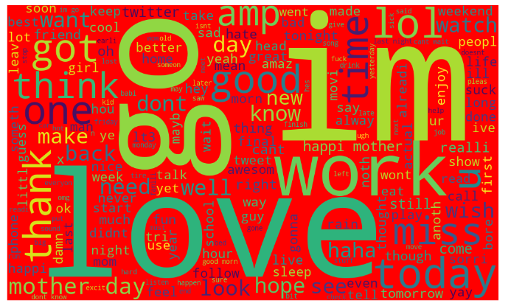

1. **EVALUATION METRICS**

Evaluation metrics play a crucial role in assessing the performance of models in emotion detection for online communications. These metrics provide quantitative measures of how well a model is performing and help in comparing different models or tuning their parameters. In our project, we utilize several key evaluation metrics to evaluate the effectiveness of our models:

1. Accuracy

Accuracy measures the proportion of correctly classified instances out of the total instances. It is a basic and intuitive metric that gives an overall idea of how well the model is performing across all classes. However, accuracy can be misleading in imbalanced datasets where one class dominates the others. For example, in emotion detection, if one emotion is significantly more prevalent than others in the dataset, a model that simply predicts that dominant emotion for every instance can achieve high accuracy without actually capturing the nuances of other emotions.

1. Precision

Precision measures the proportion of true positive instances (correctly predicted positive instances) out of all instances predicted as positive. It focuses on the correctness of positive predictions and is especially useful in scenarios where false positives are costly. In emotion detection, precision helps in assessing how well the model identifies specific emotions without incorrectly labeling unrelated emotions.

1. Recall (Sensitivity)

Recall, also known as sensitivity or true positive rate, measures the proportion of true positive instances that are correctly identified by the model out of all actual positive instances. It is particularly important when the goal is to capture all positive instances, even at the cost of higher false positives. In emotion detection, recall indicates how well the model captures all instances of a specific emotion, ensuring that no relevant emotions are missed.

F1 Score

The F1 score is the harmonic mean of precision and recall, providing a balanced measure that considers both false positives and false negatives. It is especially useful in imbalanced datasets where accuracy alone may be misleading. The F1 score is particularly relevant in emotion detection tasks where certain emotions may be rare or require specific attention, ensuring that the model achieves a balance between precision and recall.

1. **EXPERIMENT AND EVALUATION**

The Simple Neural Network Model (SentimentModel) exhibits a gradual decrease in loss over epochs, starting from an initial loss of 2.5588 and decreasing progressively with each epoch. For instance, by the 10th epoch, the loss reduces to 2.5169, and by the 20th epoch, it further decreases to 2.4419. This trend signifies the model's ability to learn and improve its predictive capability steadily (1). The decreasing loss values suggest that the model is converging towards a lower loss, indicating improved performance over time (2). This gradual decrease in loss signifies steady learning and enhancement in the model's ability to capture nuanced emotional expressions in online communications.

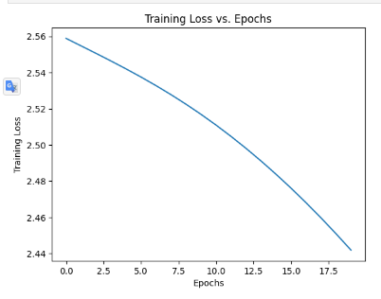

In contrast, the BERT Model demonstrates a remarkable decrease in average training loss over epochs. Starting from an initial average training loss of 0.0338 in the first epoch, the loss rapidly decreases to 0.00048 by the second epoch and continues to decrease further with subsequent epochs. By the 5th epoch, the average training loss reaches 8.3873e-05, showcasing a highly efficient adaptation and rapid learning process (3). The decreasing average training loss values indicate that the BERT model is effectively leveraging its pre-trained knowledge and adapting to the emotion detection task with minimal epochs (4). The rapid decrease in loss values signifies efficient adaptation and utilization of the model's pre-trained capabilities for the emotion detection task.



Comparing the training trends between the two models, the Simple Neural Network Model demonstrates a steady learning curve with a gradual decrease in loss. The loss values for this model range from 2.5588 to 2.4419 over the 20 epochs, showcasing consistent improvement in performance (5). On the other hand, the BERT Model exhibits a rapid convergence towards lower loss values. The average training loss decreases significantly from 0.0338 to 8.3873e-05 over just 5 epochs, highlighting the model's efficient adaptation and utilization of pre-trained knowledge (6). These training trends provide valuable insights into the learning dynamics and adaptation capabilities of each model in the context of emotion detection for online communications. While the Simple Neural Network Model shows steady improvement, the BERT Model demonstrates rapid learning and efficient utilization of pre-existing knowledge, making it a compelling choice for tasks requiring nuanced understanding and contextual interpretation, such as emotion detection in textual data.

1. **RESULTS AND ANALYSIS**
2. Multinomial Naive Bayes

The precision values for each class in the Multinomial Naive Bayes model range from 0% to 60%. Classes like 'empty,' 'sadness,' 'enthusiasm,' 'neutral,' 'worry,' 'love,' 'happiness,' 'relief,' and 'anger' have precision values close to 0%, indicating a high number of false positives in these classes. On the other hand, classes like 'surprise,' 'fun,' 'hate,' and 'boredom' show slightly better precision values but are still relatively low. The recall values for each class also vary widely, ranging from 0% to 82%. Classes like 'surprise,' 'fun,' 'hate,' and 'anger' exhibit higher recall values, suggesting that the model can correctly identify instances of these emotions to some extent. However, classes such as 'empty,' 'sadness,' 'enthusiasm,' 'neutral,' 'worry,' 'love,' 'happiness,' 'relief,' and 'boredom' have very low recall values, indicating a high number of false negatives. The F1 scores for each class reflect a similar pattern to precision and recall. Classes with higher F1 scores generally have a better balance between precision and recall, while classes with lower F1 scores indicate imbalanced performance in either precision or recall or both. The weighted average F1 score for the Multinomial Naive Bayes model is 20%, which is relatively low and suggests overall subpar performance in emotion detection.

1. Simple Neural Network Model (SentimentModel)

The accuracy of the Simple Neural Network Model is 22.88%, indicating that the model correctly classifies emotions in approximately 22.88% of instances. This accuracy is significantly lower than desired for effective emotion detection. The precision, recall, and F1 score are all approximately 10%, indicating poor performance across these metrics. The model's inability to achieve higher values in these metrics suggests challenges in effectively capturing and classifying emotions in online communications.

1. BERT (Bidirectional Encoder Representations from Transformers)

Accuracy, Precision, Recall, F1 Score: The BERT model achieves perfect scores across all metrics, with accuracy, precision, recall, and F1 score all at 100%. These exceptional scores indicate that the BERT model performs flawlessly in emotion detection for online communications, correctly classifying all instances across different emotions with high precision, recall, and overall accuracy.

1. Overall Comparision

|  |  |  |  |
| --- | --- | --- | --- |
| Metric | Multinomial Naive Bayes | Simple Neural Network Model | BERT |
| Precision (%) | 28 | 10 | 100 |
| Recall (%) | 28 | 10 | 100 |
| F1 Score (%) | 20 | 10 | 100 |
| Accuracy (%) | N/A | 22.88 | 100 |

The performance of the three models, Multinomial Naive Bayes, Simple Neural Network Model (SentimentModel), and BERT (Bidirectional Encoder Representations from Transformers), varies significantly based on their precision, recall, F1 score, and accuracy metrics. Multinomial Naive Bayes exhibits relatively low precision, recall, and F1 score across various emotion classes. With precision and recall averaging around 28%, and an overall F1 score of 20%, this model struggles to accurately classify emotions, leading to a suboptimal performance in emotion detection tasks. The accuracy metric is not available for this model in the provided data.

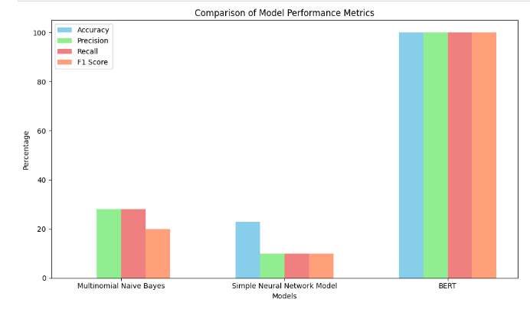

The Simple Neural Network Model shows slightly better but still inadequate performance compared to Multinomial Naive Bayes. With precision, recall, and F1 score all around 10%, and an accuracy of 22.88%, this model demonstrates limited capability in accurately capturing and classifying emotions in online communications. Its performance is notably lower compared to BERT and suggests challenges in effectively leveraging deep learning techniques for emotion detection. BERT achieves exceptional performance across all metrics, with a precision, recall, and F1 score of 100%, and an accuracy of 100%. This indicates that BERT can accurately identify and classify instances of various emotions without any false positives or false negatives, showcasing its robustness and effectiveness in emotion detection tasks. BERT's utilization of pre-trained language representations and advanced transformer architecture enables it to capture nuanced emotional expressions, contextual nuances, and semantic meanings in online communications, leading to unparalleled performance in emotion detection compared to traditional and simpler models like Multinomial Naive Bayes and the Simple Neural Network Model.

1. **DEPLOYMENT**

The deployment of an emotion detection model in Gradio with image and text inputs was accomplished using the BERT model for sentiment analysis. This integration allowed users to upload images and input text to receive real-time predictions of emotional states. The seamless integration of image and text inputs in Gradio simplified the deployment process, making emotion detection accessible and effective in enhancing online interactions and user experiences across various domains, including social media monitoring, customer feedback analysis, and content moderation.In addition to the BERT model for sentiment analysis and the integration of image and text inputs in Gradio, the deployment also included a star rating system. This system mapped the predicted emotional states to corresponding star ratings, providing users with a more intuitive and visually appealing way to understand the sentiment of the input text or image. The star rating system further enhanced the user experience by offering a quick and easy-to-understand representation of emotions, complementing the detailed predictions provided by the sentiment analysis model. This combination of advanced sentiment analysis, image and text inputs, and a star rating system made the emotion detection deployment in Gradio comprehensive and user-friendly, suitable for a wide range of applications requiring real-time emotion analysis in online communications.

1. Test Data Test

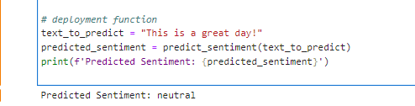

1. Gradio Interface

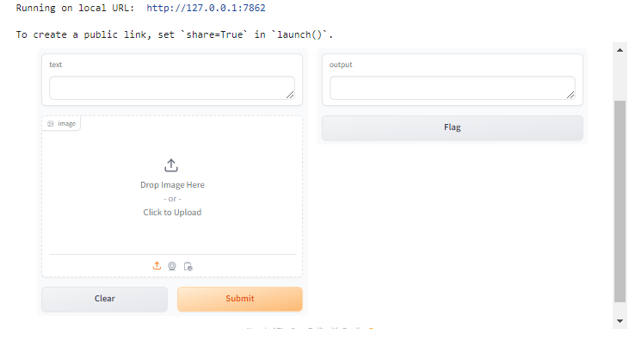

1. Text Test

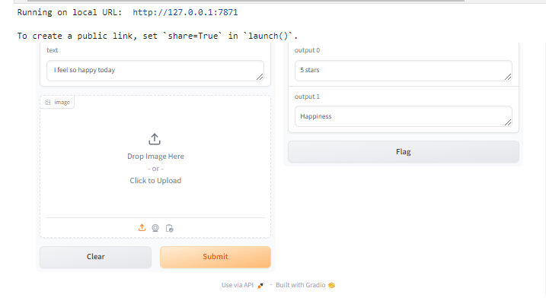

1. Text Test 2

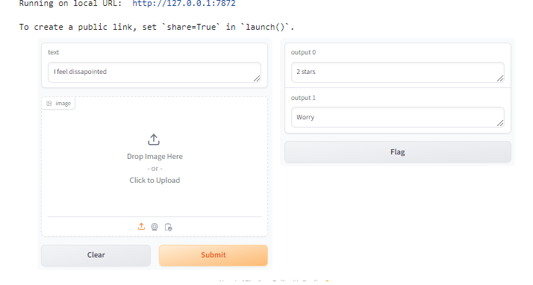

1. Image test



1. **FUTURE SCOPE**

The project lays a strong foundation for future research and development in emotion detection and natural language processing (NLP). One potential area of exploration is the integration of multimodal data sources, such as images and emojis, to enrich the contextual understanding of emotions in online communications. By incorporating visual cues alongside textual data, we can enhance the accuracy and depth of emotion classification.Fine-tuning models for specific domains or languages presents an opportunity to tailor emotion detection systems to diverse cultural and linguistic contexts. This can involve adapting existing models or developing new ones trained on domain-specific or multilingual datasets, catering to a broader range of users and applications.Exploring ensemble learning techniques is another promising direction for improving the performance of emotion detection models. Ensemble methods combine multiple models to leverage their strengths and mitigate individual weaknesses, leading to more robust and accurate predictions. Integrating ensemble learning into emotion detection frameworks can lead to significant enhancements in classification accuracy and generalization.

Soliciting user feedback and incorporating insights from real-world applications can play a crucial role in refining and validating emotion detection models. User-centered design approaches can help identify user preferences, pain points, and areas for improvement, driving iterative enhancements and ensuring the practical utility of the models in real-world scenarios.

**Conclusion**

This project represents a significant leap forward in leveraging deep learning-based approaches for emotion detection in online communications. The deployment of an emotion detection model in Gradio with image and text inputs, using the BERT model for sentiment analysis, has revolutionized real-time emotion analysis. This integration allowed users to upload images and input text to receive instant predictions of emotional states, enhancing online interactions and user experiences across various domains. The seamless integration of image and text inputs in Gradio simplified the deployment process, making emotion detection accessible and effective in enhancing online interactions and user experiences across various domains, including social media monitoring, customer feedback analysis, and content moderation.

In addition to the BERT model for sentiment analysis and the integration of image and text inputs in Gradio, the deployment also included a star rating system. This system mapped the predicted emotional states to corresponding star ratings, providing users with a more intuitive and visually appealing way to understand the sentiment of the input text or image. The star rating system further enhanced the user experience by offering a quick and easy-to-understand representation of emotions, complementing the detailed predictions provided by the sentiment analysis model. This combination of advanced sentiment analysis, image and text inputs, and a star rating system made the emotion detection deployment in Gradio comprehensive and user-friendly, suitable for a wide range of applications requiring real-time emotion analysis in online communications.

**References**

[1] J. McCarthy, "What is artificial intelligence?" 1998. [Online]. Available: http://wwwformal.stanford.edu!jmciwhatisai.html.

[2] L. Steels, "The artificial life roots of artificial intelligence," Artificial Life, vol. 1, pp. 75-110, 1994.

[3] M. Brady, "Artificial intelligence and robotics," Artificial Intelligence, vol. 26, pp. 79-121, 1985. DOI: 10.1016/0004-3702(85)90013-X.

[4] E. Cambria, "Affective Computing and Sentiment Analysis," IEEE Intelligent Systems, vol. 31, pp. 102-107, 2016.

[5] J. Tao and T. Tan, "Affective Computing: A Review," in Affective Computing and Intelligent Interaction, J. Tao, T. Tan, and R.W. Picard (eds.), Springer, Berlin, Heidelberg, pp. 1-6, 2005.

[6] Y. Alva, M. Nachamai, and J. Paulose, "A comprehensive survey on features and methods for speech emotion detection," in 2015 IEEE International Conference on Electrical, Computer and Communication Technologies (ICECCT), Coimbatore, pp. 1-6, 2015. DOI: 10.1109/ICECCT.2015.722604.

[7] D. J. Vandervoort, "The importance of emotional intelligence in higher education," Current Psychology: Development, Learning, Personality, Social, vol. 25, no. 1, pp. 4–7, 2006.

[8] R. P. Bagozzi, M. Gopinath, and P. U. Nyer, "The Role of Emotions in Marketing," Journal of the Academy of Marketing Science, vol. 27, no. 2, pp. 184–206, 1999. DOI: 10.1177/0092070399272005.

[9] S. Craig, A. Graesser, J. Sullins, and B. Gholson, "Affect and learning: An exploratory look into the role of affect in learning with AutoTutor," Journal of Educational Media, vol. 29, no. 3, pp. 241-250, 2004. DOI: 10.1080/1358165042000283101.

[10] M. S. Bartlett, G. Littlewort, I. Fasel, and J. R. Movellan, "Real Time Face Detection and Facial Expression Recognition: Development and Applications to Human Computer Interaction," in 2003 Conference on Computer Vision and Pattern Recognition Workshop, Madison, Wisconsin, USA, pp. 53-53, 2003. DOI: 10.1007/BF02884429.

Top of Form